Abstract Figure

Let me know if any extra changes are needed. These figures were developed after the meeting on January 13, 2025. Subjects included for the analysis are: 001, 002, 003, 004, 005, 006, 007, 008, 019, 020, 021, 022, 023, 024, 026, 027, 028, 029, 030, 031. The discomfort data is updated from the previous abstract submission by Dr. Hughes. The updated data is here:

None (choice=Yes) Lead: 33, Rampart: 17

Total Lead Discomfort Counts: 58

Total Rampart Discomfort Counts: 29

Lead has more discomfort counts.

Overall Mean for All Participants Discomfort Counts: 0.01061888169902107 (When 1 = checked and 0 = unchecked)

# Potential Abstract Figure 1:

* 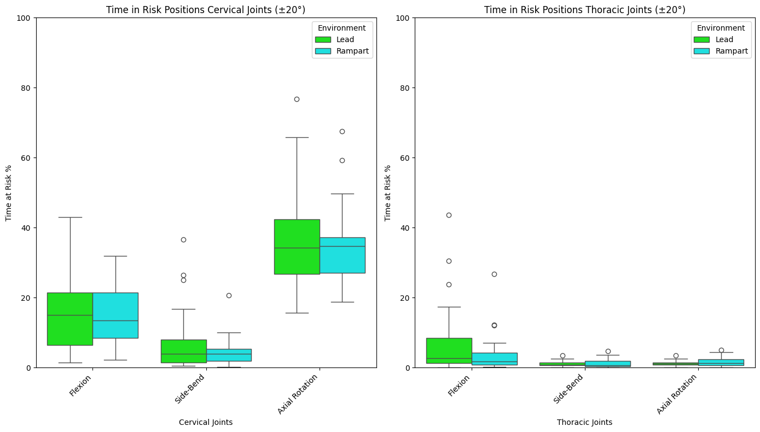
* Lead vs. Rampart Box Plot Statistics for Figure 1:
* Let me know if any of those values appear confusing, but any of those can be used for the abstract paper noting the values. The statistics are found in the traditional fashion of box plot stats. If you have any questions about how I found these, I can explain them to you.
  + 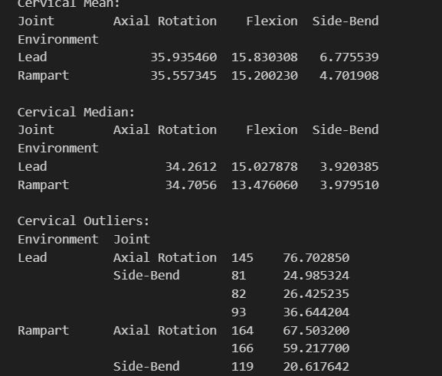
  + 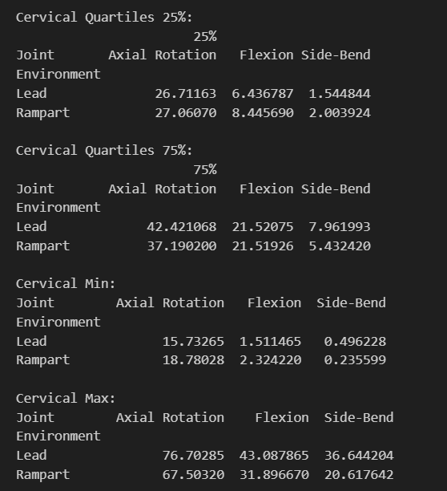
  + 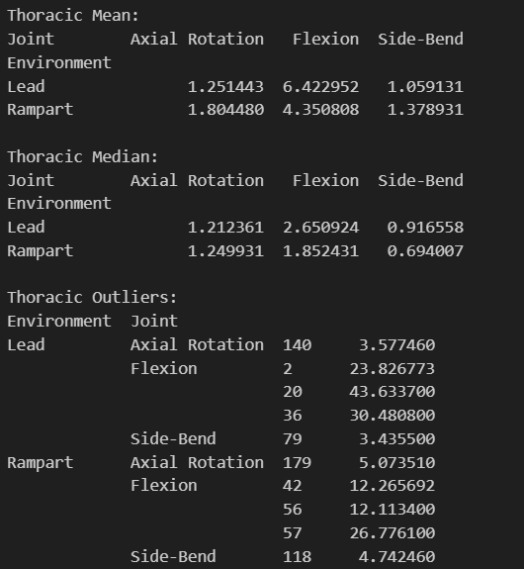
  + 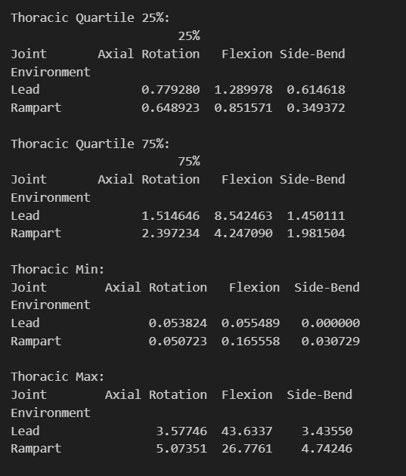

# Potential Abstract Figure 2:

* 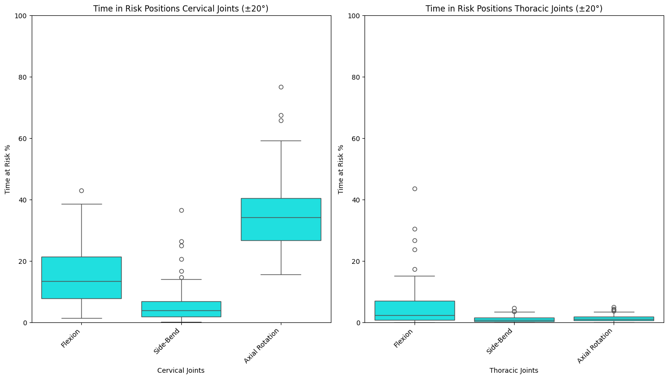
* The box plot above is the combined sum of duration including all lead and rampart cases.
* Box Plot Statistics for Figure 2:
  + 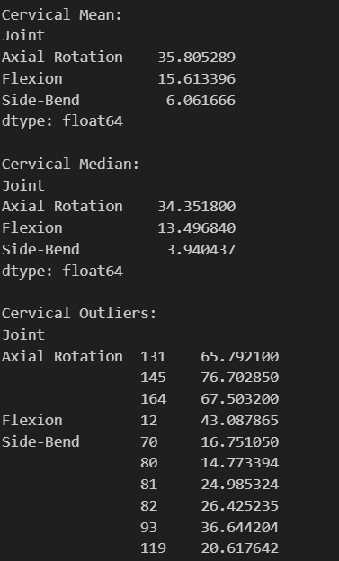
  + 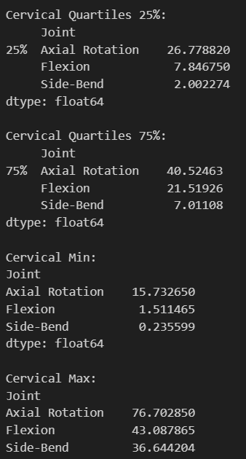
  + 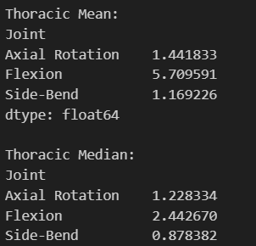
  + 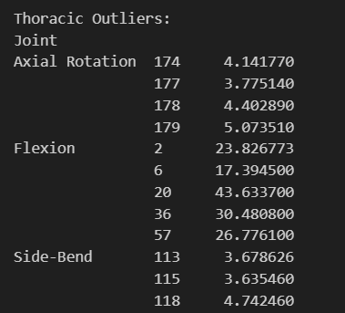
  + 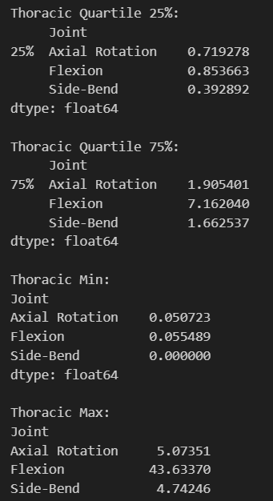

# Potential Other Figures:

* Looking at the Gender differences:
  + 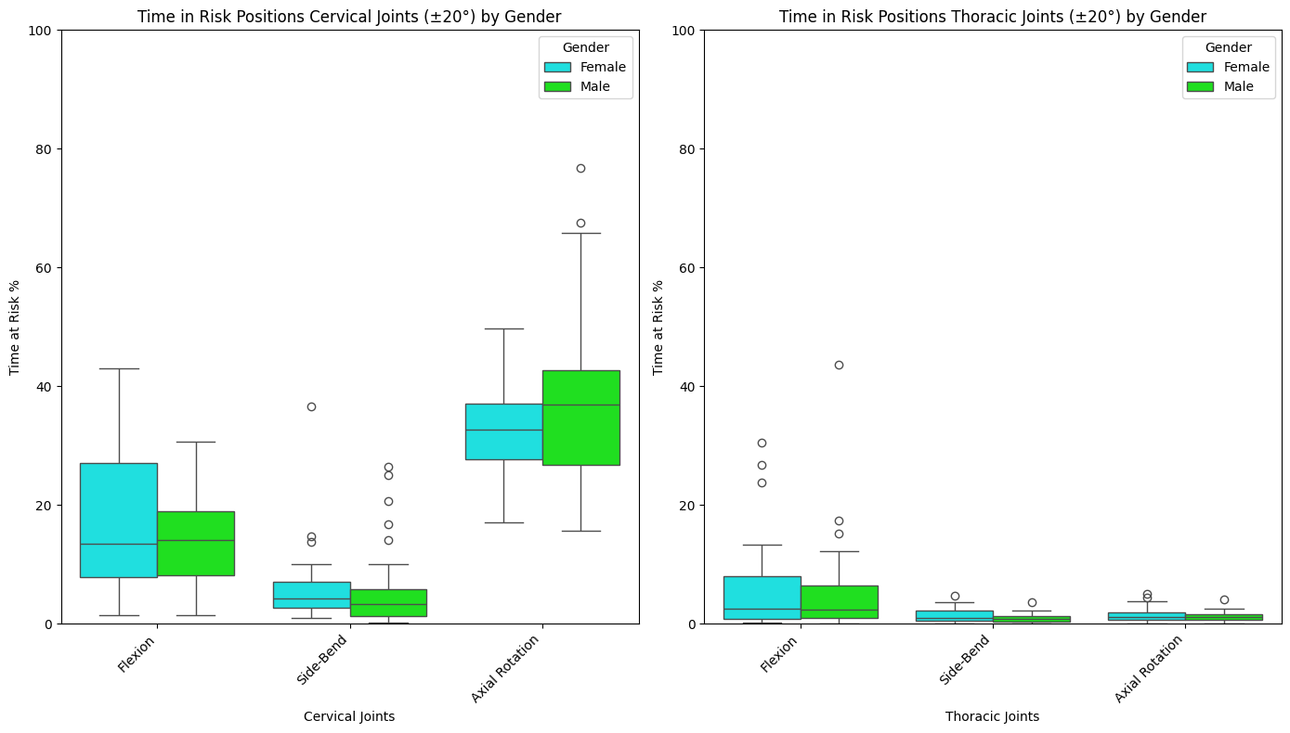
    - Box Plot Gender Stats:
    - 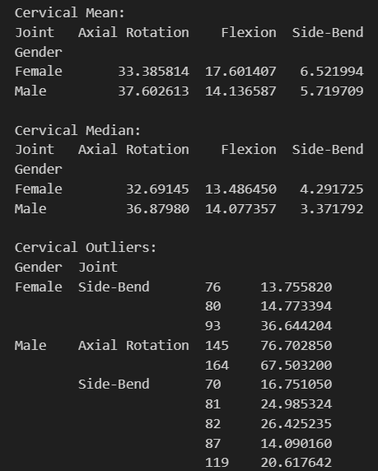
    - 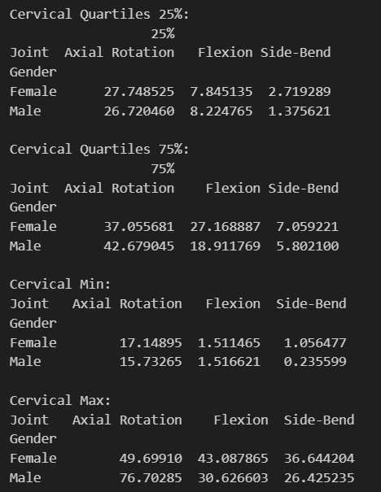
    - 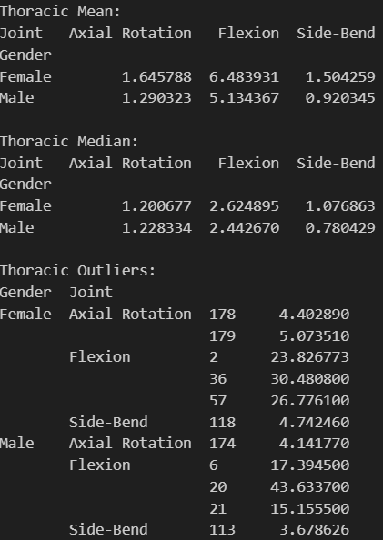
    - 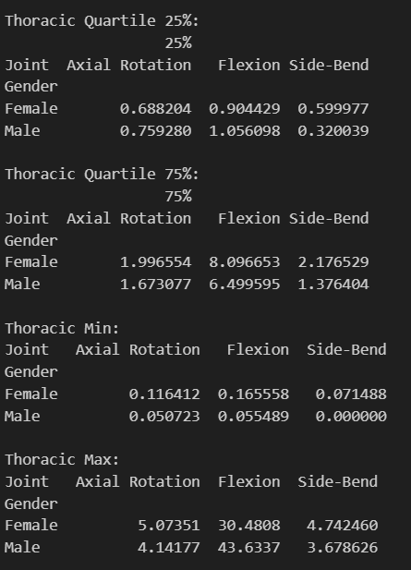
* Looking at the Stratification by Case Length:
  + 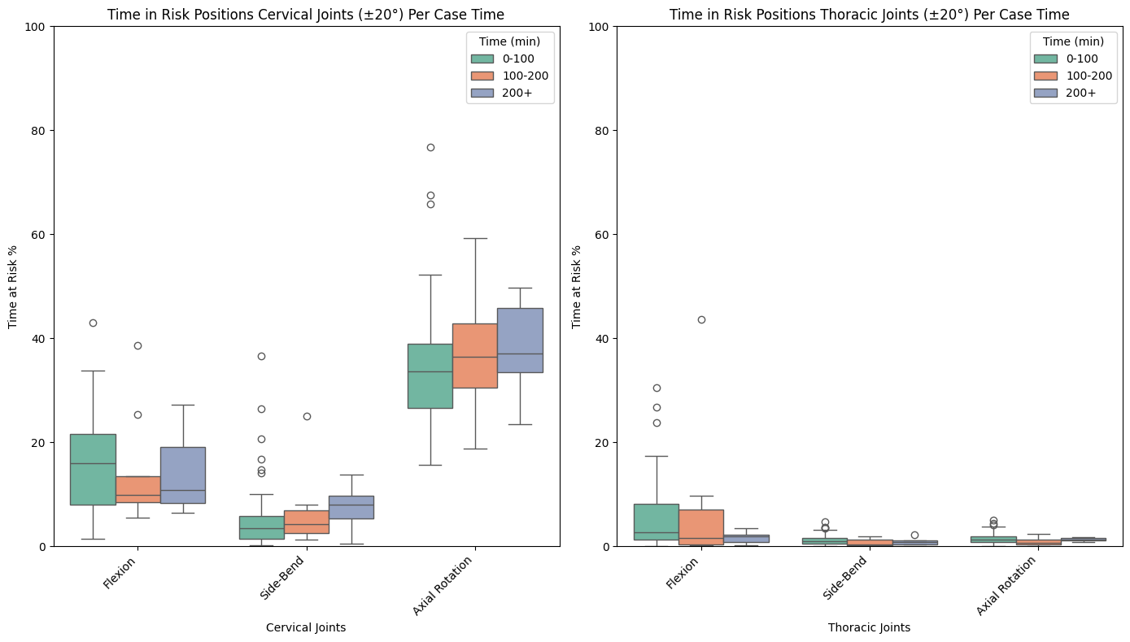
    - Box Plot Time Stats:
    - 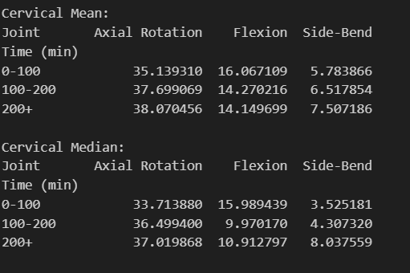
    - 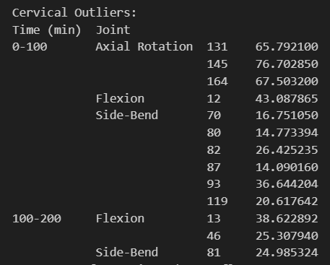
    - 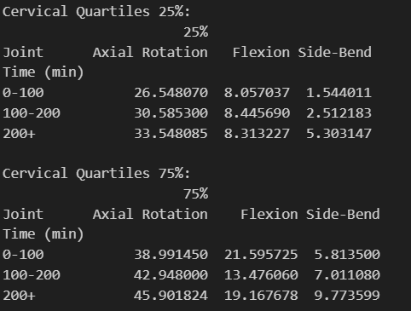
    - 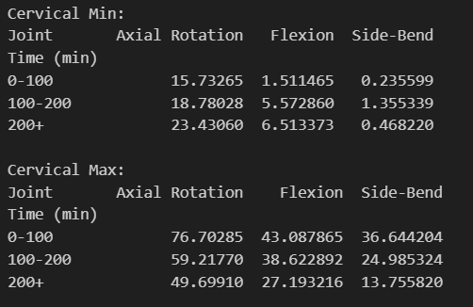
    - 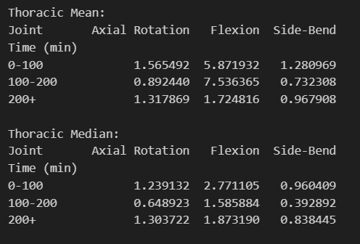
    - 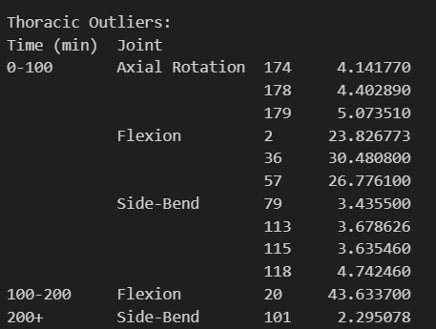
    - 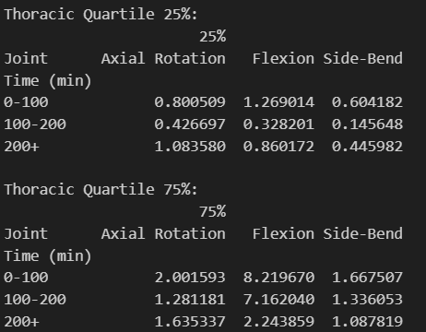
    - 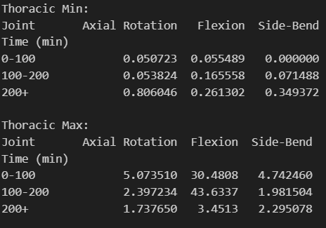
* Looking at the Stratification by Role:
  + 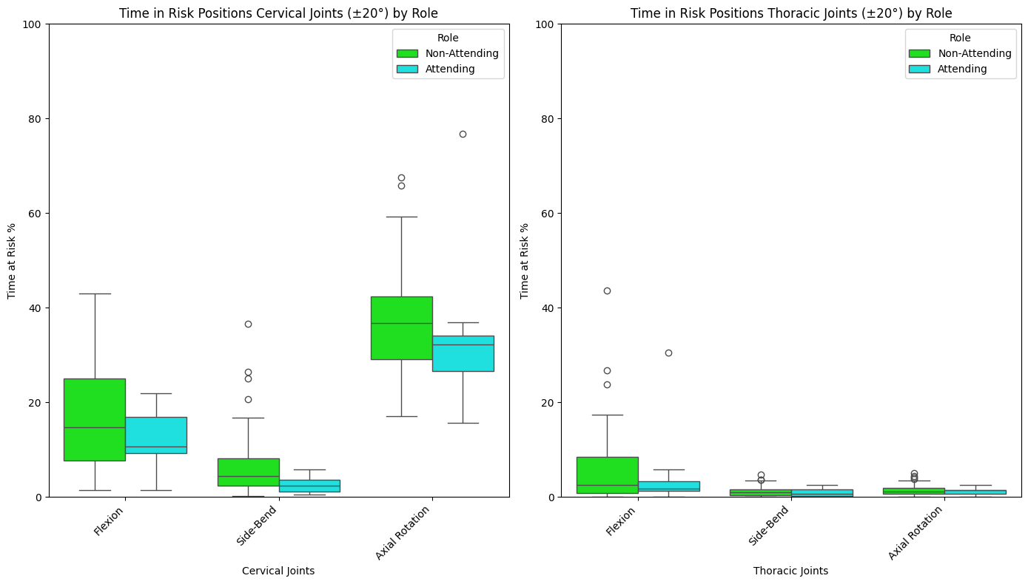
    - Box Plot Role Stats:
    - 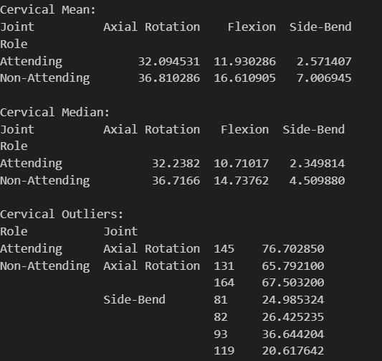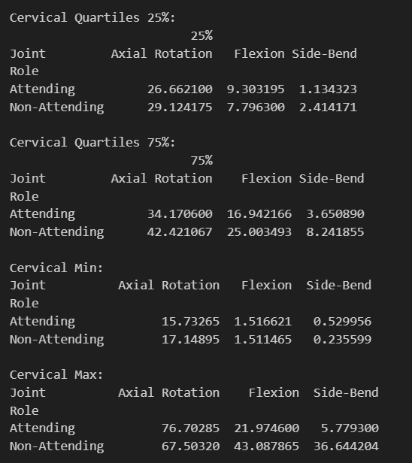
    - 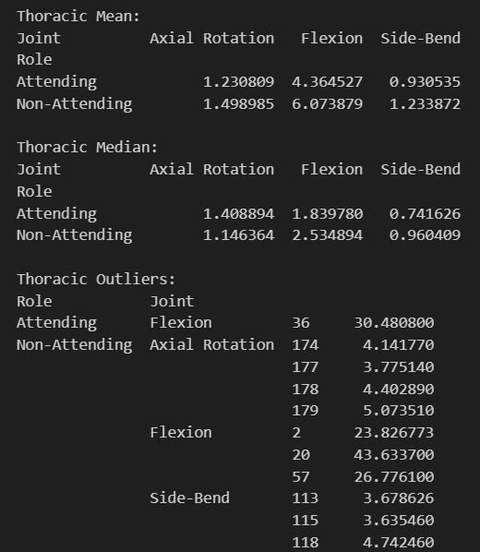
    - 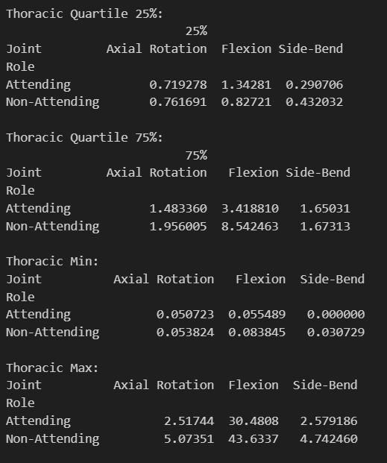

# Concluding Thoughts:

* I can change any of the graphs to a bar plot again.
* Let me know if you need to change anything on the plots or would rather focus on one thing in particular.